ACDP user manual

date：13th Jul., 2022

1. App installation：

**Android phone** please download from this link，or open your phone browser to scan the QR code to download it directly.

<http://www.acdpmaster.com/en/resource-download/Download.html>

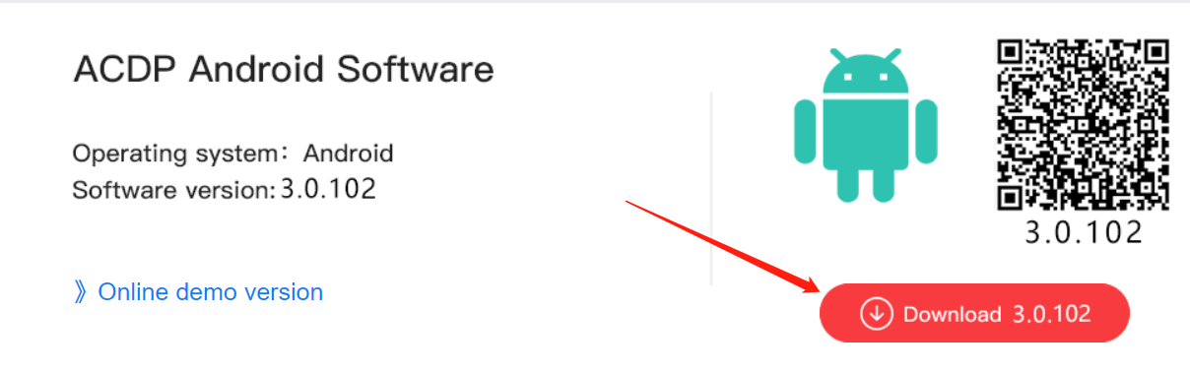

If you failed to download from official web，pls try this link

<https://mega.nz/file/ivpjzTBT#_u__prM14LIjlEbH1MXxi30nlGjzH1Rf81AeK6a62Jk>

**IOS phone** please go to app store 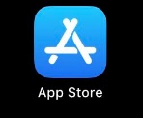 to search “acdp”to download and install.

**PC version** please go to web to download the software，unzip the folder，then open ACDP directly

<http://www.acdpmaster.com/en/resource-download/Download.html>

**or**

<https://mega.nz/file/bioiXaKL#XXxho4U3kSXRQ_Dg4HclU4I5vvKO4VjFnwvVYiNLmNc>

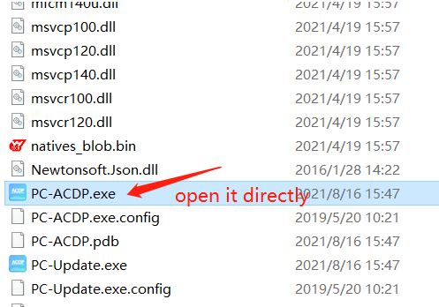

If you can open it please download the running environment and install.

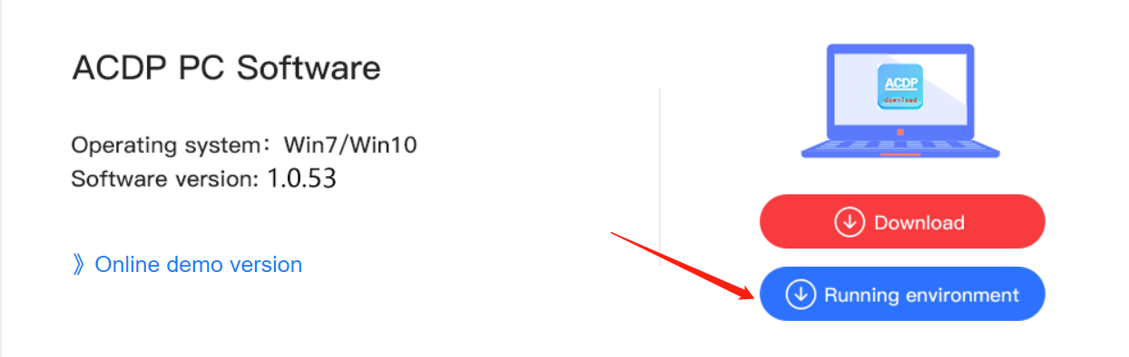

1. ACDP bound with device：

There are all kinds of videos in ACDP app，

Or visit YouTube for more.

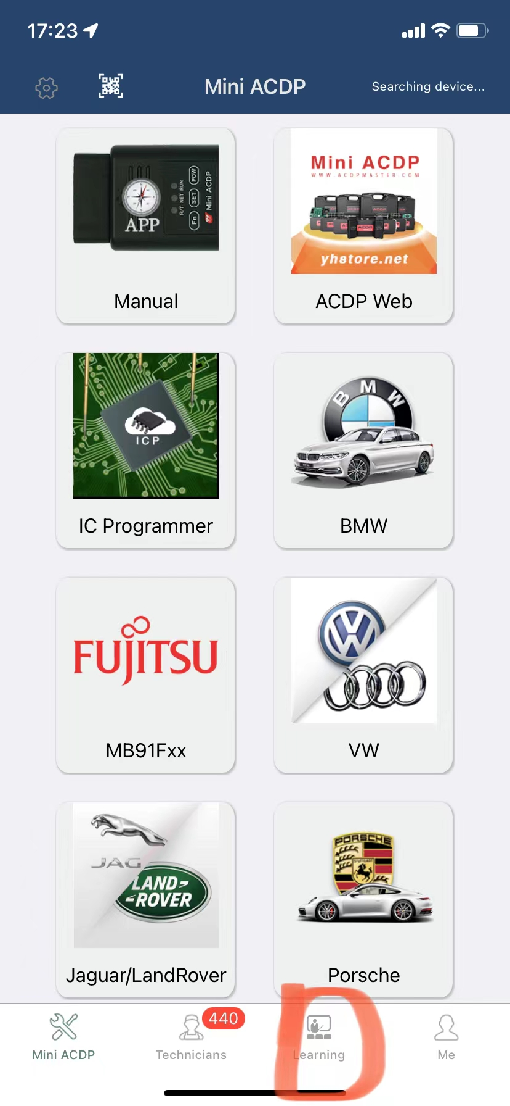

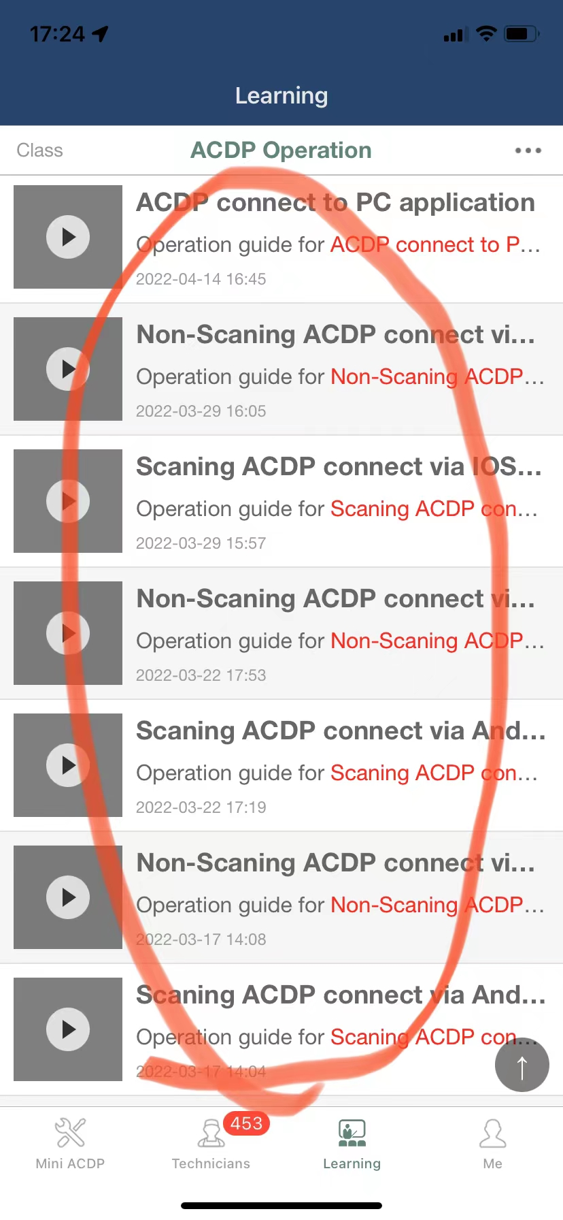

1. device activate：please take off the green sticker on the module box，then you will find a QR code and a 8-digit code like EXXXXX，then open the ACDP app，click me-module list-add-scan the QR code or enter 8-digit code-submit，then it can active this module.

There are also video to guide you how to do in the app lessons.

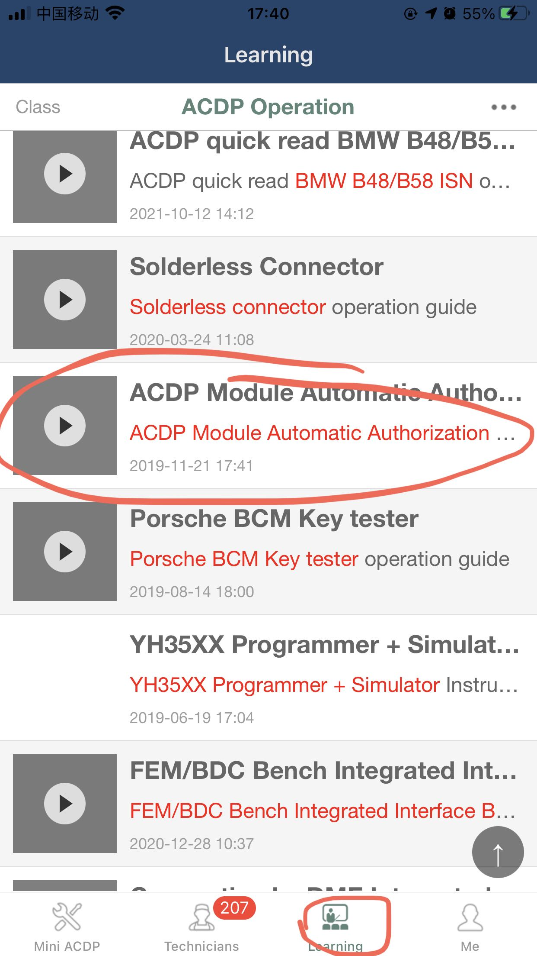

1. Technician account.

This is an account to let you talk with technician online，you still can use the app

even you don’t have an technician account.

Please register it like the following.

